Project Progress Report (2025 version)

Name of Project: Green Production and Sustainable Development in Secondary Aluminum, Lead, Zinc and Lithium Sectors in China

Date of report: 12/29/2025

A. PROJECT PROFILES

Quantum Project ID | 6492
Project overall duration | 12/1/2024-15/9/2029
Location(s) | Jiangxi, Hubei, Anhui, Zhejiang, Guangdong, Tianjin, Guangxi
Implementing partner | Foreign Environmental Cooperation Center (FECO), Ministry of Ecology and Environment (MEE)
Responsible party (if any) | N/A
UNDP Programme Officer | HONG YUN

Gender Marker (GEN 1/2/3) | GEN 2
Relevant CPD 2021-2025 output | Output 2.1: Adaptive policies developed at target level (subnational), financed and applied for nature-based systems to align with multilateral agreements and transboundary platforms.
Relevant SP output | Output 4.1 Natural resources protected and managed to enhance sustainable productivity and livelihoods

***

2025 Annual budget in System | USD 2,645,970
2025 Expenditure | USD 2,018,883 (will be updated once CDR finalized)
2025 Delivery rate | 76%

B. RESULTS

B.1 Results Towards the Annual Work Plan

Guidance.
- STEP 1: Copy and paste the “2025 Project Outcome – Output (or Project Output – Activity)” and “2025 Indicator, baseline, and annual target” from the signed 2025 AWP/TYWP into columns A, C, D, and E of the below table.
- STEP 2: In column B, report project results achieved in 2025 with narratives supported by credible evidence and segregated data, and record the 2025 indicator value in column F (per UNDP CO Audit 2025 recommendation 5b).

A. Project outcome/output statement  (2025 AWP) | B．2025 Project Results, backed up by evidence and segregated datal | C. Indicator Statement  (2025 AWP) | D. Baseline Level  (2025 AWP) | E. Annual Target  (2025 AWP) | F. Value as of 2025
Outcome 1.1 Reduced UP-POPs and BFRs releases resulting from unsound metal scrap and batteries recycling management practices through the adoption and implementation of standards/measures, policies, plans, laws, regulations and guidance. | During the reporting period, the project successfully completed procurement and finalized contracts for the development of eight standards. To date, six of these standards have been officially published and released.  - Including: Technical Specifications for Pollution Control in the Secondary Zinc Industry. The formulation of the group standard aims to standardize pollution control measures across all links of secondary zinc production. It addresses the lack of clear requirements regarding process characteristics, pollutant types, and emission control in practical secondary zinc production, providing a reference for national policy implementation, environmental supervision, and cleaner production audits. This standard further promotes the development of secondary zinc processes toward green, standardized, and efficient directions.  - Evaluation Criteria for Low-Carbon Enterprises in Secondary Metal (Aluminum, Lead, Zinc, Lithium) Smelting. The group standard will fill the gap in standard development. It addresses the current lack of targeted evaluation criteria for low-carbon enterprises in secondary metal smelting—a gap that has hindered the in-depth advancement of "dual-carbon" efforts in the sector. Additionally, it will provide strong support for improving the national "dual-carbon" standard system and advancing the industry's low-carbon transition.  - Guidelines for Performance Evaluation of Commercial Promotion Models for End-of-Life Electric Vehicle Dismantling. The formulation of the group standard marks a key step in the development of performance evaluation systems in the field of end-of-life electric vehicle dismantling. The release of this standard will fill gaps in the industry, provide a scientific and systematic evaluation framework for the commercial promotion models of end-of-life electric vehicle dismantling, and help address issues such as "the lack of a unified and clear performance evaluation system", "the need for dismantling process optimization and benefit improvement", and "the enhancement of policy support and supervision".  - Guidelines for Standardized Recycling Management of Waste Lead-Acid Batteries. The group standard specifies requirements for recyclers' operational norms, safety protection, data traceability, and supervision throughout the entire waste lead-acid battery recycling process. It will guide standardized operations for personnel involved in links such as individual waste lead-acid battery recyclers, collection outlets, and centralized transfer stations, and contribute to guiding the healthy and sustainable development of the industry.  - Guidelines for Pollution Control of Brominated Flame Retardants (BFRs) in the End-of-Life Vehicle Recycling and Dismantling Industry. The group standard addresses the widespread presence of BFRs in end-of-life vehicles and their potential environmental risks. It intends to provide systematic pollution control guidance, covering key links such as BFRs source identification, classification and collection, storage and transportation, treatment and disposal, pollution control and environmental protection, emergency management, record-keeping and reporting, as well as training and responsibility assignment. The formulation of this standard will not only fill the gap in relevant management norms of the industry.  - General Technical Specifications for Reusable Parts of End-of-Life Motor Vehicles. The national standard is a core foundational standard in the standard system for reusable parts of end-of-life motor vehicles. It specifies technical requirements and code of conduct throughout the production and circulation of reusable parts, filling the technical gap in the industry and addressing prominent issues such as market disorder and unstable quality caused by the current lack of standards. The promotion of this standard will greatly enhance the safety and reliability of reusable parts, providing more secure products for consumers.  The development of the remaining two standards is currently on track and ongoing.  1)Waste Zinc and Zinc Alloy. The revision of the national standard aims to establish a standardised definition for recycled zinc resources in light of the current state of the recycled zinc industry. This addresses the conflict between the original standard and China's existing ‘zero import of solid waste’ policy, thereby promoting the recovery, utilisation and trade of recycled zinc raw materials within the country. It contributes to environmental protection, energy conservation and low-carbon development, and advances the green and sustainable development of the nation's manufacturing sector and economy.  2)Requirements for the Construction of Logistics Traceability Information Management System for Waste Power Batteries of New Energy Vehicles. The industrial standard will address issues faced by regions, industries, and enterprises in aspects such as the architecture, application functions, system, and data security of logistics traceability information systems for waste power batteries of new energy vehicles. It will help further strengthen process supervision in this field.  These standards advance sectoral decarbonization, circular economy practices, and regulatory robustness—directly supporting China’s "dual-carbon" goals while addressing critical industry pain points.  We have launched a joint research initiative with other institutions in nine technical and policy areas, among which five research topics have completed acceptance. The five topics that have passed acceptance include:  1)Research on Pollution Control in Utilization and Disposal of Secondary Zinc  2)Research on Environmental Management Policies for Lithium-Ion Power Battery Recycling Industry  3)Research on Environmental Management Methods for Hazardous Wastes and Brominated Flame Retardants in End-of-Life Vehicle Recycling and Dismantling Processes  4)Research on Eco-Design Pathways and Policies for Green Batteries  5)Research on Evaluation Criteria for Low-Carbon Enterprises in Secondary Metal (Aluminum, Lead, Zinc, Lithium) Smelting  These five research topics have all submitted their correspongding policy recommendatiion reports.  The Department of Ecology and Environment of Hubei Province（Demonstration Province for this Project） has issued the "Letter on Further Strengthening the Construction of Hubei Province's Carbon Footprint Management System", which provides solid institutional support and practical pathways for green, low-carbon and high-quality development. | Indicator 5:  Number of technical standards finalized  Indicator 6:  Effectiveness of policy implementation | 0  0 | At least 2 technical standards  At least 1 evaluation report on effectiveness of existing policy implementation and suggestions | 6 standards  5 report
Output 1.1.1 Policy and regulatory framework for metal scrap management developed, revised and improved and relevant components integrated into the existing policy and regulatory framework.
Output 1.1.2 Technical by-laws, regulations and guidance aiming to reduce UP-POPs and BFRs release from batteries manufacturing, recycling and disposal practices developed, adopted and implemented.

Outcome 2.1 Reduced releases of UP-POPs and BFRs as a result of improved raw material (recycled metal scrap and batteries) supply chains as well as the introduction of environmentally sound disposal practices and extended producers responsibility at recycling entities. | As of the end of 2025, the project has entered its second phase，and the demonstration enterprises are actively advancing the upgrading of technologies and equipment.  Five enterprises have completed the acceptance of the Phase II objectives, with their progress as follows:  1) Zhejiang Tianneng Power Source Co., Ltd. has accomplished the second-phase project objectives include the achievement of fully enclosed production for all production lines. A full-life-cycle authorized traceability management information system for lead-acid batteries based on the "Internet + Recycling" model has been established.  2) Guangxi Weiyun Renewable Resources Recycling Co., Ltd. has completed the construction of 10 planned self-built waste battery collection points, while 2 are operating normally with the existing hazardous waste management permits. The APP for the Guangxi Hazardous Waste Collection and Transportation Information Service Platform has been developed and is currently undergoing operational testing in 4 cities.  3) Anhui Lukong Environmental Protection Co., Ltd. have been designated as regional lead-acid battery recycling demonstration units under the full life-cycle value chain initiative, with cooperation agreements signed in October. The technical transformation of the combustion system specified in the objectives has been completed. Currently, the construction of the rooftop photovoltaic (PV) power station is in progress, and all transformation work is expected to be fully completed by March 2026.  4) Wuhan Power Battery Recycling Technology Co., Ltd. has been selected to showcase the battery recycling system, with 21 recycling service stores established so far. It also uses information technology to enable traceability of waste battery circulation data. The TMS (Transportation Management System), WMS (Warehouse Management System), and MES (Manufacturing Execution System) subsystems involved in the professional recycling platform for lithium-ion power batteries have been constructed and integrated online.  5) Maoming Tianbao Renewable Resources Development Co., Ltd. The company has established an intelligent management model and a corresponding information system to control BFRs-related risks. Currently, this system is capable of recording and managing information regarding BFRs and hazardous wastes in end-of-life vehicles, and realizing information-based traceability through electronic tags. In conjunction with the launch of this system, the company has also continuously strengthened internal management measures and corresponding work systems for hazardous wastes.  To address the environmental and social impacts of the projects, an expert team was invited to conduct ESIA for each project. At present, Guangxi Weiyun, Anhui Luknog and Maoming Tianbao have completed the corresponding assessment. The assessment for Zhejiang Tianneng and Wuhan Dongli is still in progress.  1) Guangxi Weiyun Renewable Resources Recycling Co. Assessment results indicate that the project has an overall minor environmental and social impact. Meanwhile, it also highlights that the project poses certain environmental and social impacts during both the construction and operation phases of its demonstration activities. These impacts include wastes and noise generated during construction, health impacts on personnel within the project scope, and environmental risks associated with hazardous wastes throughout the process.  In line with the assessment findings, a detailed ESMP has also been formulated to conduct continuous monitoring and evaluation.  - Anhui Lukong Environmental Protection Co., Ltd. Conclusions from the assessment indicate that this demonstration project will yield significant environmental, social, and economic benefits. The environmental and social impacts primarily stem from risks associated with the construction process, while the overall environmental impact is minimal and controllable. Therefore, during the subsequent implementation of the project, only appropriate mitigation and management measures need to be adopted to effectively control negative impacts.  - Maoming Tianbao Renewable Resources Development Co., Ltd. Assessment results indicate that the project has an overall minor environmental and social impact. Meanwhile, it also highlights that in addition to the conventional construction and operation risks, the solid waste generated during the drying process of the dismantling phase requires proper disposal. Furthermore, as third-party contractors are involved in the operation phase, emphasis must also be placed on the health and safety risk management of personnel associated with these contractors. In line with the assessment findings, the expert team has formulated a detailed ESMP to ensure the smooth implementation of the demonstration activities.  Demonstration provinces:  The two demonstration provinces are advancing their work steadily as planned. Both Jiangxi and Hubei Provinces carried out popular science activities on World Environment Day (June 5th) to enhance enterprises' awareness of green production and help the public understand the tangible impact of sustainable development on daily life.  Additionally, Jiangxi Province held the "2025 Jiangxi Provincial Special Training on Hazardous Waste Environmental Management" on May 29-30th. The training targeted both relevant administrative authorities and personnel from enterprises in the related industries. During the session, participants were briefed in detail on the latest hazardous waste treatment technologies, technical standards, management methods, and ledger establishment procedures. | Indicator 7:  Battery recycling demonstration models in waste lead-acid battery  Indicator 8:  Battery recycling demonstration models in waste lithium ion battery | -  - | At least 1 waste LAB recycling pilot program initiated  At least 1 feasible waste LIB recycling model established | Anhui Lukong's LAB recycling pilot program has been launched  Zhejiang Tianneng’s LIB recycling system has been launched
Output 2.1.1 Assessment of existing collection systems completed, and appropriate collection schemes established, feasible legislative arrangements, including proper acceptance and outbound material criteria.
Output 2.1.2 Supply chains for local markets further developed, recycling rates increased and maximum quantities of recyclable plastic parts diverted from inadequate disposal.

Output 2.1.3 Two demonstration projects implemented to demonstrate BAT/BEP and life cycle recycling in the collection and conditioning of waste batteries (one in lead acid batteries and one in lithium ion batteries), applying proper management of hazardous waste generated in the whole process.
Outcome 2.2 Prevent and minimize the generation of UP-POPs in the secondary metallurgical processes. | As of the end of 2025, during the second phase of the project, demonstration enterprises involved in the initiative are actively advancing technological transformation, with some of the transformation projects specified in the objectives yet to be completed.  Progress of the two relevant demonstration enterprises is as follows:  1) Tianjin Xinlizhong Alloy Group Co., Ltd. The furnace insulation renovation has been completed. The transformation of the aluminum dross harmless treatment and waste disposal system is in progress. For the green production and dust removal system, supplier selection has been finished and it is now in the procurement cycle. The plant expansion project is also advancing steadily. All renovations are expected to be completed between July and August 2026.  - Jiangxi Hongcheng Alumin Co., Ltd. The procurement, installation and commissioning of the eddy current separator, X-ray sorting equipment and SCR denitration device have been completed. The renovation of the raw material pretreatment workshop is in progress. In addition, the enterprise is actively advancing internal digital transformation and upgrading. All upgrading work is expected to be completed in July 2026.  To address the environmental and social impacts of the projects, an expert team was invited to conduct ESIA for each project. At present, Jiangxi Hongcheng has completed the corresponding assessment. The assessment for Tianjin Xinlizhong is still in progress.  - Jiangxi Hongcheng Alumin Co., Ltd. Assessment results indicate that, except for the moderate impact on the occupational health and safety of construction personnel, the demonstration project has minimal other environmental and social impacts. Therefore, it is emphasized that for subsequent construction personnel, management and training need to be continuously strengthened, and appropriate protective measures should be provided to control risks.  Two enterprises to participate in the regenerated zinc demonstration program, Henan Jinli Gold and Lead Group Co., Ltd. and Fuxin Chengtai Environmental Protection Technology Co., Ltd., have completed the pre-assessment, including expert review and on-site assessment. Contract negotiations with the two enterprises are planned to be conducted. | Indicator 9:  BAT/BEP demonstration in SAl sectors  Indicator 10:  BAT/BEP demonstration in SZn sectors | -  - | At least 1 BAT/BEP technical routes established  At least 1 BAT/BEP technical routes established | The proposal from Tianjin Xinli Zhong Group has been approved and is now in the equipment procurement phase.  Contract negotiations are under way with two demonstration enterprises
Output 2.2.1 Assessment of secondary metallurgic production processes and technologies finalized.
Output 2.2.2 Three to five (3-5) demonstration projects implemented to demonstrate BAT/BEP in the secondary production of metals (in aluminum, zinc and End of Life vehicles dismantling).
Outcome 3.1 Replication and Promotion of demonstration results and experience | As this is the Second year of the project implementation, the NRP has not been started. The project team will systematically integrate the operational experience and successful case studies derived from the pilot initiatives into the scale-up strategy.  Best practices and evidence-based insights from the demonstration phase will be institutionalized in the replication framework under PMO coordination. | Indicator 11:  National replication plan  Indicator 12:  Promotion plan design and implementation | -  - | National replication plan incorporating experience gained developed.  Dismantling and smelting enterprises designed and implemented. | None  None
Output 3.1.1 A national replication plan of sustainable recycling and green production developed.
Output 3.1.2 Results of the implemented demonstration project published and disseminated for replication.
Outcome 3.2 Promotional events for stakeholders, including awareness raising delivered | As of the end of 2025, with project support, two science popularization videos have been produced - one focusing on POPs pollution prevention and control, and the other on gender mainstreaming. Hubei province has actively participated in both the design and promotion of these videos.  In addition, up to now, two popular science videos on gender mainstreaming integrates knowledge related to gender mainstreaming into the recycled metal industry in a vivid and intuitive way. It not only expands the coverage and influence of science popularization, enabling more people to easily understand and accept this concept, but also further strengthens the public's awareness of gender equality.  A training manual specially designed for the project, titled as “Promoting Gender Equality in Secondary Metal Industry” has been completed, which includes the strategies and approaches to enhance women’s empowerment in secondary metal industry.  The training materials on promoting gender equality in the non-ferrous metals industry, compiled by Project Gender Specialist, have been completed. They are soon to be used for public education and awareness-raising activities targeting demonstration projects, as well as the industrial parks and communities where these projects are located, so as to popularize knowledge on gender mainstreaming from more perspectives.  In addition, the project has produced a promotional poster and a promotional video that unfold the project from different dimensions, always emphasizing the affinity of communication. Moreover, in May 2025, combined with the United Nations Sustainable Development Goals and the gecko image of the project logo, 17 different cartoon images have been created, continuing to uphold the communication concept of "small hands pulling big hands".  Three thematic popular science promotional videos have also been produced focusing on secondary metals and lithium-ion batteries. These videos use accessible and easy-to-understand formats to educate the general public on the vital significance of secondary metals, laying a solid foundation for the promotion and publicity of the relevant demonstration activities involved.  The demonstration enterprises are also actively advancing internal training and external promotion during the same period. The details are as follows:  1. Zhejiang Tianneng has conducted 20 internal training sessions focusing on themes of technology, standards, and gender equality. The cumulative number of participants has exceeded 12,000 person-times, with an average training duration of 33.68 hours per person. Among them, female employees have an average training duration of 35.69 hours per person.  In terms of external promotion, it has covered villages and towns around the industrial park (such as Hengjian Village and Huicheling Village) as well as primary and secondary schools, reaching over 3,000 people. Meanwhile, it delivered a keynote speech based on the project’s work at the 2025 National Conference on Green and Low-Carbon Innovation and Development.  2.Anhui Lukong has completed 16 class hours of themed internal training, with the training content mainly focusing on the learning of professional skills related to energy conservation and emission reduction.  In terms of external promotion, it has covered other enterprises within the industrial park where it is located, surrounding communities as well as primary and secondary schools. Meanwhile, by means of measures such as painting project promotion information on transport vehicles, it has achieved communication coverage of more than 20,000 people.  3.Guangxi Weiyun has completed the production of promotional materials related to hazardous waste, which will be placed at collection points in various cities in the future.  Meanwhile, it has conducted skill training on hazardous waste management for staff of auto repair shops in Nanning, covering approximately 500 people.  In addition, the enterprise has cooperated with the government to promote battery recycling, including participating in the 22nd China-ASEAN Expo and carrying out promotional activities at Guangxi Materials School.  4.Wuhan Dongli has carried out a total of 14 training sessions on hazardous & special operation management and control within the company, with the number of participants exceeding 700.  Meanwhile, the enterprise has invited people from all walks of life to visit the company and learn about power battery recycling knowledge, receiving a total of more than 3,600 visitors.  In terms of external promotion, the enterprise has also actively participated in the 20th International Conference on Solid Waste Management and Technology to showcase its latest achievements. In terms of media promotion, it has also featured in special reports on battery recycling on CCTV-2 and Hubei TV. | Indicator 13:  Knowledge products and promotion materials  Indicator 14:  Training and promotional activities | -  - | 1 Knowledge product based on lessons learned developed and disseminated.  5 Training sessions, promotion and public awareness activities conducted | 6 popularization videos.  1 popularization poster  1 gender quality training materials  More than 50 training sessions and coverage by two media outlets.
Output 3.2.1 Technical training for stakeholders and awareness raising workshops developed and implemented.
Output 3.2.2 Awareness raising materials formulated and distributed
Outcome 4.1 Project monitoring and evaluation | As of the end of 2025, the project team has been strengthened with the addition of a gender specialist and a safeguards expert to oversee the implementation of gender-responsive activities and social and environmental safeguards (SES), ensuring full compliance with the Gender Action Plan and SES requirements.  As of now, in accordance with the project management requirements,  a. 1 PSC meetings(March 7th)  b. 2 Project Coordination Meeting(January 8th & April 21st)  c. 2 project progress report  d. 2 Verifications  e. 1PIR  f. 1 joint project mission  The Mid-Term Review has not yet started. The project team will ensure the relevant data are collected during the implementation phase to fully prepare for the MTR. | Indicator 15:  Timing and quality of annual (APRs, PIRs etc.) and M&E reports  Indicator 16:  Quality appraisal in Mid-Term Review and Terminal Evaluation | -  - | M&E activities implemented as scheduled and on budget, project implementation monitored to achieve project objectives  Matters identified for adaptive management | a. 1 PSC meetings  b. 2 Project Coordination Meeting  c. 2 project progress report  d. 2 Verifications  e. 1 PIR  f. 1 joint project mission  g. 9 Contractual Services-Companies  h. 2 Contractual Services Individuals  None
Output 4.1.1
M&E activities undertaken with annual review, mid-term review, social and economic assessment, mid-term review and terminal evaluation conducted and project performance evaluated.
Outcome 4.2  Knowledge sharing and information dissemination | Two gender-related knowledge training sessions were organized and held online.  On June 20, the Workshop on Gender Mainstreaming and Women's Rights Protection in the Secondary Metals Industry was held, with the participation of 20 enterprises. On October 15, the Workshop on Promoting Gender Equality in the Secondary Metals Industry was held, attended by 14 enterprises. | Indicator 17:  Lessons learnt and experience documented and disseminated; post-project action plan formulated and workshops conducted |  | Lessons and experience documented and disseminated through 2 workshops conducted to benefit 200 direct and 600 indirect beneficiaries
Outcome 4.2  Knowledge sharing and information dissemination | A technical exchange mission on recycled metals was conducted in Belgium and the Netherlands in Oct 2025, where China's national policies and industry demonstration experience in this field wereshared during the mission | Indicator 18:  International knowledge and experience gained
[+]

B.2 Project Impact

Guidance: It is crucial to maintain a broader perspective that connects the dots between overall project activities, outputs, outcomes, and impact. In Section B.2, please go beyond discussing immediate activities and focus on the long-term impact of the project. Use 1-2 paras (more are welcome) to discuss:

(a) how the project informs policy-making process in China and/or
(b) how this project has contributed to broader societal, economic, or environmental goals of China, and/or
(c) how it contributes to national and local priorities, etc.

During PPR 2025 process, UNDP China will identify PPRs that demonstrate clear and tangible policy impact. Selected PPRs will be featured in a special “UNDP China Policy Impact Report 2025”. We encourage every project to take Section B.2 seriously, and we will follow up with teams whose submissions are selected. Thank you in advance!

In 2025, the "China Green Production and Sustainable Development Project for Secondary Industry of Aluminum, Lead, Zinc and Lithium" has continued to advance steadily, essentially meeting its expected targets. It not only provides ongoing support for the green development of relevant industries but also actively strengthens the leadership role of demonstration enterprises. Below is a detailed overview of the progress:

(I) Policy Recommendations

During the project implementation, demonstration enterprises have actively combined their practical experience with international advanced technology application cases to address gaps in China’s operational standards – specifically in three key areas: pollution control and carbon emission management for recycled metals, environmental management for battery recycling, and hazardous waste management for end-of-life vehicle dismantling.

Working with industry technical experts, these enterprises have facilitated the refinement and formulation of 8 standards, providing advanced experience and references for the industry. Additionally, the two participating demonstration provinces – Jiangxi and Hubei – have developed management improvement plans from a government perspective. While supporting enterprise development, they have also enhanced the capacity for environmental impact control, and promoted the implementation and scaling of green development models through a series of measures.

Looking ahead, the project will collaborate with other research institutions to conduct research and propose solutions for 8 policy and advanced technology themes. This multi-perspective effort will further supplement and improve the policy framework, ensuring the successful achievement of project outcomes.

(II) Enterprise Green Development

Currently, all demonstration projects are actively drawing on the BAT/BEP route to transform their production processes, with the aim of reducing UP-POPs emissions and achieving energy conservation and low-carbon goals.

In this process, expert teams have evaluated the ESMP of each demonstration project and produced corresponding ESIA reports, helping enterprises improve their environmental health management systems. To date, demonstration enterprises have conducted over 50 internal training sessions to enhance employees’ awareness of safe and healthy production, and to strike a balance between environmental impact control and safe, healthy operations.

These training initiatives not only promote environmental health concepts but also improve employees’ professional capabilities – equipping them to meet the higher production requirements after green transformation and enhancing enterprises’ overall competitiveness. From the perspective of the project’s overarching goals, the gradual improvement of demonstration enterprises is expected to drive the industry’s overall development, and further elevate the green development level of Chinese enterprises in relevant sectors.

(III) Technical R&D Cooperation

During the implementation of this project, the project team has actively carried out scientific research cooperation with multiple institutions, focusing on improving the technical capabilities of pollution control and environmental management for secondary metals and Persistent Organic Pollutants (POPs), which has provided solid scientific research support for the steady implementation of demonstration projects. Meanwhile, it has continuously deepened the close cooperation mechanism among governments, scientific research institutions and industrial enterprises, promoted the efficient integration of policy guidance, technological innovation and industrial practice, and jointly contributed to the green and high-quality development of the industry.

In the scientific research work of this phase, cooperative units have focused on key links of secondary metals such as secondary aluminum, lead, zinc, lithium and related industries to conduct in-depth technological R&D, and formed core research results covering five dimensions: pollution control, resource regulation, low-carbon development, information management and performance evaluation. The release and application of these results not only provide key technical support for the industry's standardization construction, green transformation and efficient operation, but also inject momentum into the promotion of China's resource sustainable utilization, ecological environmental protection and manufacturing industry upgrading strategies from the perspective of industrial practice, strongly supporting the achievement of green economic growth and social sustainable development goals.

(IV) Social Impact

In this phase, demonstration enterprises and provinces have promoted the concepts of green development and resource recycling and reuse to over 30,000 members of the general public across the country through active training and publicity efforts. Notably, content related to gender equality has been integrated into these activities to ensure that the concepts of "green development" and "equality" take root in public awareness.

Currently, women account for over 30% of participants in promotion activities – both within enterprises and among social institutions. Looking ahead, more women will be encouraged to participate. Meanwhile, demonstration enterprises are leveraging this green development transformation to create additional positions in technological R&D and digital management, providing more opportunities for women to engage in these fields.

In conclusion, the steady progress of the project has laid a solid foundation for achieving its final overarching goals. The successful advancement of this project will not only provide strong support for China’s progress in recycled metals, battery recycling, and UP-POPs management – driving the green transformation of Chinese enterprises – but also offer valuable insights and practices for the global achievement of sustainable development goals.

C. RISK MANAGEMENT

Guidance. Please refer to the "Risk Log/Register" annex in the project document. Then (a) provide updates on the existing risks entries and their corresponding treatments. And (b) document any new risks identified in 2025 in the table below, if any.

# | Updates on valid risk entries on risk log with treatments | Identification of new risks emerging in 2025 (if any)
1 | The six demonstration projects have undergone Environmental, Social and Economic Impact Assessments (ESIA) conducted by expert teams on the enterprises. Corresponding assessments and risk warnings have also been provided in response to the risks mentioned earlier.  Furthermore, under the tripartite collaboration of the project management team, expert team, and enterprises, efforts are being made to promote the active improvement of Environmental and Social Management Plans (ESMPs) by all demonstration enterprises. Currently, in their 2025 progress reports, various enterprises have provided, to varying degrees, corresponding institutional improvement plans, environmental, health and safety (EHS) management regulations, as well as publicity and training programs for internal employees.  Regarding the impact on the external society and environment, in line with the overall publicity requirements of the project and based on the conditions of their respective locations, the demonstration enterprises have also engaged in publicity activities in communities and other social institutions, actively fostering a sound social atmosphere. | 1.We should strengthen publicity to spread project experience and results from different perspectives of international and domestic.  2.More attention should be paid to gender equality. Women should be encouraged to participate in the demonstration of new technologies and digitalization, and the positive effects of women in skills training and multi-job participation should be actively disseminated.  3.We must adjust work plans promptly based on actual project implementation to expedite the effective execution of all task indicators and achieve expected goals. Currently, multiple projects are in the construction phase, making progress control particularly challenging.  4.The audit report indicates that overall expenditure progress has been relatively slow, with payment rates of 72% and 71% in Q1 and Q2 2025 respectively.

2

[+]

D. GENDER

Guidance. please provide details on incorporation of gender perspectives in various aspects of project management. Please provide quantitative data, qualitative case studies and success stories whenever necessary to illustrate the most significant contributions to gender equality.

Please choose the Gender marker rating of this project: ☐GEN-3; ☒GEN-2; ☐GEN-1

Results and Contributions
Please elaborate on the results and contributions this project has made to ONE or MULTIPLE relevant Gender Equality Strategy 2022-2025 priority areas of work during the reporting year. Please provide relevant evidence to support the claims.
1 | Promote women’s economic empowerment, employment, and access to resources, and diminishing the structural barriers in economies that keep women behind. | The project ensures women’s rights in employment and provides training on new skills. For instance, Zhejiang Tianneng conducted 20 internal training sessions where female employees achieved an average duration of 35.69 hours, exceeding the overall average of 33.68 hours. The project also encourages women to take on technological R&D and digital management positions.
2 | Support the incorporation of gender considerations into local economic and social development plans, accelerate women’s equal representation in local governance, especially in rural areas. | A gender mainstreaming action plan has been developed with specific indicators. A project gender specialist and a safeguards expert have been added to the team to oversee the implementation of gender-responsive activities and ensure compliance with the Gender Action Plan. Relevant thematic training materials have been developed. Going forward, joint publicity and education activities will also be carried out in the respective regions in collaboration with gender equality specialists from enterprises participating in the demonstration activities and government departments.
3 | Support building gender-responsive resilience to a wide range of shocks and crises, including conflict, climate change, disasters, environmental degradation and epidemics. | The project provides training on specific job skills and the environmental impacts of UP-POPs/BFRs. A training manual titled “Promoting Gender Equality in Secondary Metal Industry” and specialized materials compiled by the Project Gender Specialist have been completed for these activities. This action shall focus on enhancing attention to the impacts of various occupational health risks in the secondary metals industry on women's health. It calls on all industry stakeholders to attach importance to the effects of occupational health risks on different demographic groups, so as to ensure a safer working environment for all workers and indirectly reduce the management risks of enterprises.
4 | Support women’s improved access, use, and control of resources, and enhance women’s participation and leadership role in climate action. | The project promotes women's participation through a management committee with adequate female representation and the appointment of gender mainstreaming coordinators in each enterprise to support decision-making. All enterprises have now assigned dedicated staff to jointly advance the achievement of this objective.
5 | Promote gender equality in green energy systems, policies, decision-making and ownership, as well as at the technical and service provision levels. | Enterprises participating in the demonstration activities, such as Tianneng (mentioned above), have been advocating for greater participation of female employees in the innovation and application of new technologies, and offered skills training, with the aim of enhancing their decision-making weight in green production.
6 | Raise awareness on gender equality and challenge the gender stereotype and biased social norms that limit women’s equal rights and opportunities. | The project has developed two videos and one training manual to disseminate the gender equality in recycled metal industry. All enterprises and provinces participating in the demonstration project have emphasized the significance of women's participation in their publicity activities, while also paying close attention to the proportion of women in all activities. Up to now, the outreach has covered over 30,000 people, among whom nearly 10,000 are women.
Resources Allocation (Mandatory)
7 | How much of the annual project budget/resources has been allocated to address the identified needs of women and men? If no investment has been made, does the project plan to increase project investment to support women’s empowerment and gender equality? | The project has allocated budget to hire a Gender Expert who will provide professional guidance and ensure the gender mainstreaming action plan with actions and indicators to integrate gender equality into project implementation.
Challenges & Lessons Learned (Mandatory)
8 | What are some key challenges/potential risks faced by the project in (further) promoting women's empowerment and gender equality? What are the possible mitigation measures the project will adopt to tackle those challenges? | The progress of gender equality initiatives in some demonstration enterprises has been relatively slow, constrained by the inherent characteristics of their sectors. A case in point is Guangxi Weiyun: in the vehicle maintenance and dismantling industry, the vast majority of maintenance engineers are male, a feature intrinsic to this occupation.
Knowledge Management (Mandatory)
9 | Have success story(ies) of female beneficiaries have been featured and shared as examples of the project’s key achievement in promoting women’s empowerment and gender equality? Are both women and men represented and visible in the communication products? | The project required in all the communication products, women images should account for at least 30%. Case studies of five outstanding women have been compiled through research, four of whom are frontline employees from non-ferrous metals enterprises, and the other one is engaged in scientific research. Through their own efforts and excellent qualities, all five women have achieved remarkable career accomplishments and serve as inspiring role models.

E. KNOWLEDGE PRODUCT & VISIBILITY

Guidance. Please provide details and URLs for all knowledge products, communications, and visibility materials of this project. This includes, but is not limited to, project websites, social media pages, media coverage, and publications, as applicable. Note that these links may serve as evidence and data sources for Section B above.

# | Details of communications activities | Date | External link (if applicable)
1 | "School-enterprise collaboration + talent empowerment" created a new model of industry-education integration  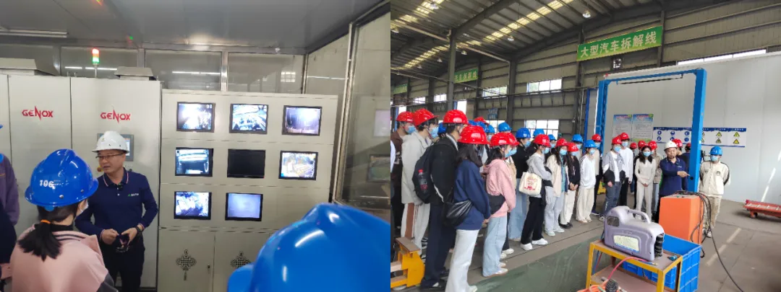 | 3/28/2025 | https://mp.weixin.qq.com/s/2YrRLmTCp4vi5EBMehoSnA
2 | The 2025 Jiangxi Provincial hazardous waste environmental management training conference was held in Nanchang | 5/31/2025 | https://mp.weixin.qq.com/s/FKScLDe4KhPsiDZkEUohNg
3 | World Environment Day: Provincial Ecological Environment Monitoring Center Launches Global Environment Facility (GEF) Project Awareness Campaign  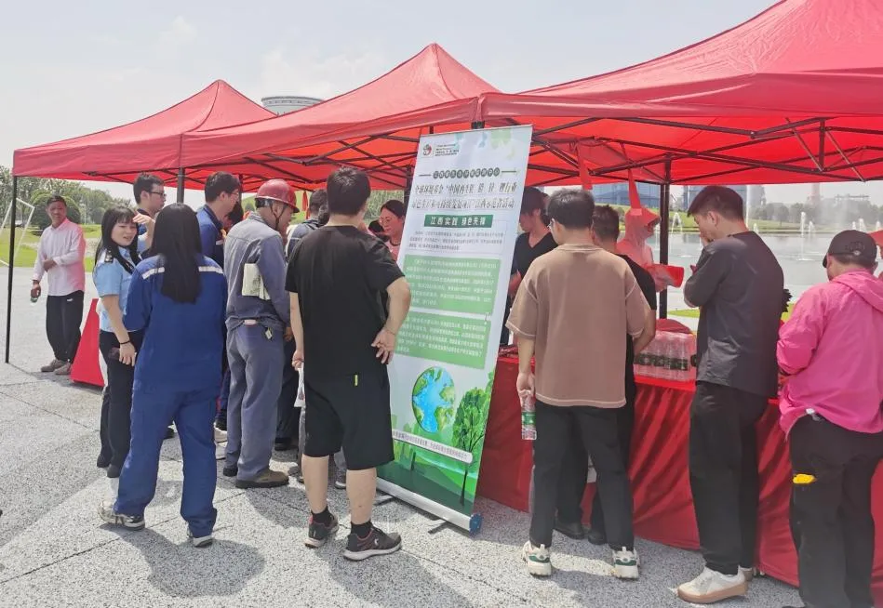 | 6/6/2025 | https://mp.weixin.qq.com/s/p-ciWZZwFSvok6lM3g-jVQ
4 | 6·5 Environment Day: Hubei Province Launches Green Production and Sustainable Development Initiative for Aluminum, Lead, Zinc, and Lithium Recycling Industries  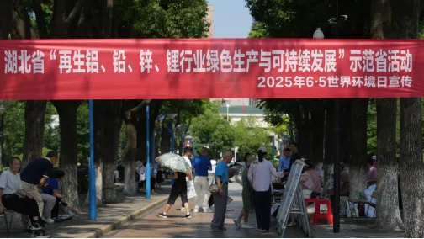  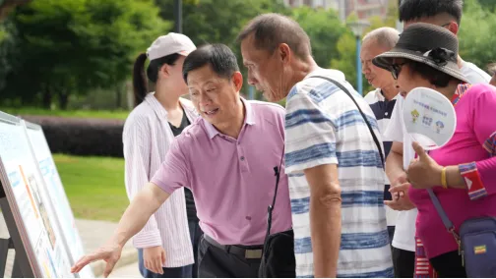  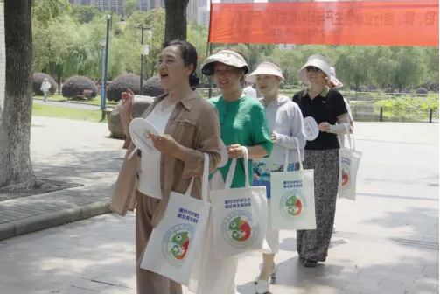 | 6/10/2025 | https://mp.weixin.qq.com/s/WBd4JnjS2luVxdBqmMA8EA
5 | Tianjin Xinlizhong Group launched a 'Best Available Technology/Best Environmental Practice (BAT/BEP) Demonstration Program' for the 6th Five-Year Plan Environment Day campaign.  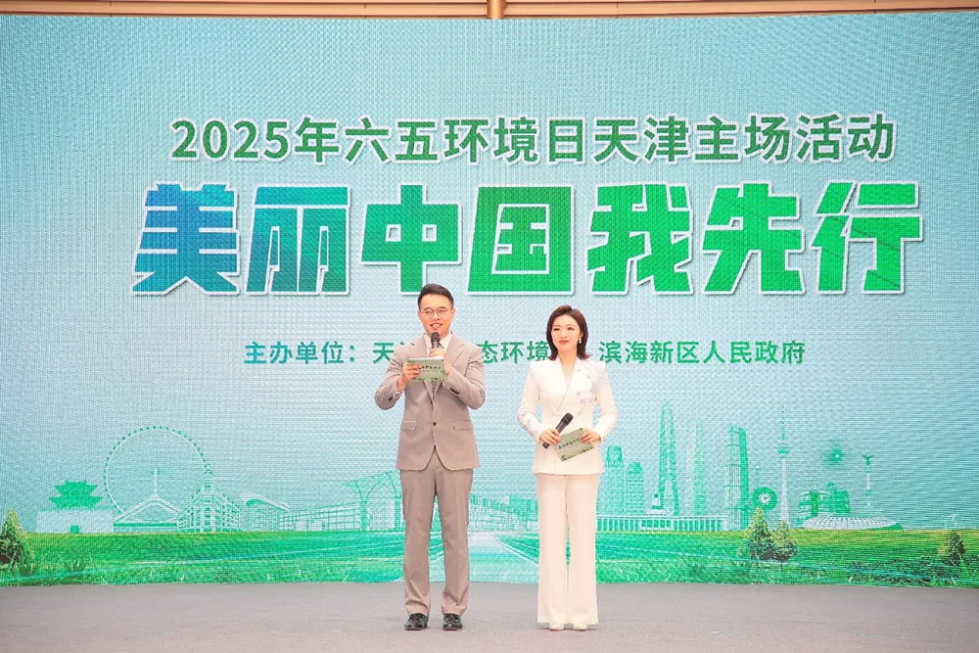  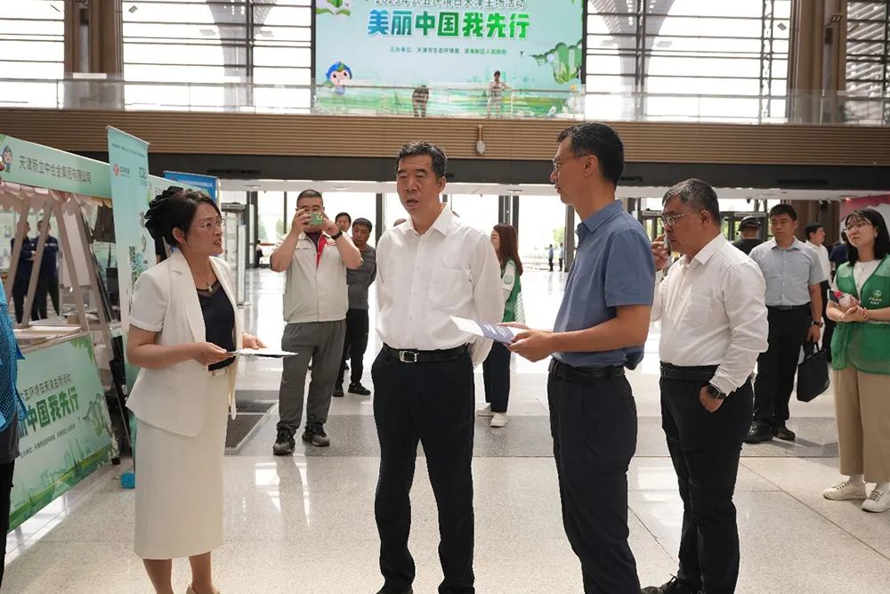 | 6/16/2025 | https://mp.weixin.qq.com/s/NyRvf28cbN1gVBEsCTmSaw
6 | Weiyun Company launched a recycling campaign for waste lead-acid batteries to promote green development in the industry.  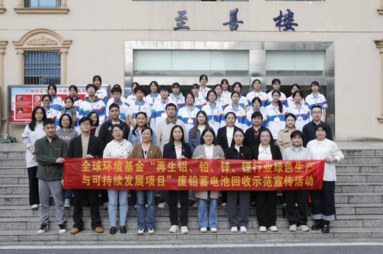 | 10/27/2025 | https://mp.weixin.qq.com/s/-L2CekffBFQladOfjMPjxQ

F. LESSONS LEARNED

Guidance.

STEP 1: Describe any results that were not achieved or were off-track in 2025. Provide an analysis on what did not work and why.

STEP 2: Based on the analysis from Step 1, propose actionable steps to adjust and correct the course of action.

# | Off-Track/Lessons Learned | Course of Action
1 | Some of the demonstration enterprises are slow in their outreach efforts, and their work on gender equality is slow because of their industry characteristics. | It is planned to summarize the experiences of enterprises that have performed well in publicity and promotion work and share them with enterprises that are progressing slowly. Meanwhile, in other subsequent research subcontracting work, emphasis should also be placed on promoting research results to the general public.  In response to the specific gender inequality issues in the industry, demonstration enterprises will continue to be encouraged to provide more positions and learning and development opportunities for female employees in the digitally-related positions and technology R&D positions planned for the future.
2 | Technical transformation and procurement cycles for demonstration projects are longer than anticipated. Several projects (e.g., Tianjin Xinlizhong and Jiangxi Hongcheng) are still in the procurement or construction phase, with completion dates expected as late as July/August 2026. The risk log identifies that progress control during this construction phase is particularly challenging. | Strengthen project lifecycle monitoring and technical support. The PMO will enhance communication with demonstration enterprises to provide technical guidance and ensure procurement cycles are streamlined. Work plans will be adjusted promptly to reflect actual implementation progress and ensure all task indicators are met on time.
3 | Lagging progress in ESIA for some demonstration sites. While some enterprises have completed their assessments, the ESIAs for Zhejiang Tianneng and Wuhan Dongli are still "in progress," which may delay the full implementation of their ESMPs. | Fast-track the remaining ESIAs and institutionalize safeguards. The project team will urge the expert team and enterprises to finalize the remaining assessments immediately. For enterprises that have completed ESIAs, the project will prioritize the practical implementation of ESMPs to mitigate identified risks, such as occupational health and noise.
4 | Gap between standard development and the initiation of the National Replication Plan (NRP). Although 6 standards have been released, the NRP has not yet started as the project is in its first year. There is a need to ensure that the practical experience gained during current technical transformations is systematically converted into the scale-up strategy. | Institutionalize demonstration outcomes at an early stage by integrating achievements from the current phase to initiate the design of the early-stage framework for the National Replication Plan (NRP). This will ensure that once demonstration projects enter the mature stage, relevant activities can be carried out simultaneously, and potential risks can be identified as early as possible through advance preparation.

Please refer to UNDP Gender Equality Strategy 2022-2025 for more details: https://genderequalitystrategy.undp.org/#

